Lab 11 – Data Structures with AI
Implementing Fundamental
Structures
NAME : J.SANJANA
BATCH : 13
ROLLNO : 2503A52379

Task Description #1 – Stack Implementation
Task: Use AI to generate a Stack class with push, pop, peek, and is_empty methods.
Input Code:
class Stack:
"""A simple Stack implementation using a Python list."""
def __init__(self):
self.items = []
def push(self, item):
self.items.append(item)
def pop(self):
if self.is_empty():
return None
return self.items.pop()
def peek(self):
if self.is_empty():
return None
return self.items[-1]
def is_empty(self):
return len(self.items) == 0
stack = Stack()
stack.push(10)
stack.push(20)
stack.push(30)
print(stack.peek())
print(stack.pop())
print(stack.pop())
print(stack.is_empty())

Output: 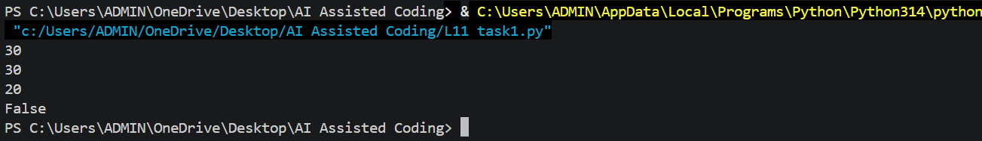 Task Description #2 – Queue Implementation
Task: Use AI to implement a Queue using Python lists.
Input Code:
class Queue:
"""A simple FIFO queue implementation using a Python list."""
def __init__(self):
self.items = []
def enqueue(self, item):
self.items.append(item)
def dequeue(self):
if self.is_empty():
return None
return self.items.pop(0)
def peek(self):
if self.is_empty():
return None
return self.items[0]
def size(self):
return len(self.items)
queue = Queue()
queue.enqueue(10)
queue.enqueue(20)
queue.enqueue(30)
print(queue.peek())
print(queue.dequeue())
print(queue.size())

OUTPUT:
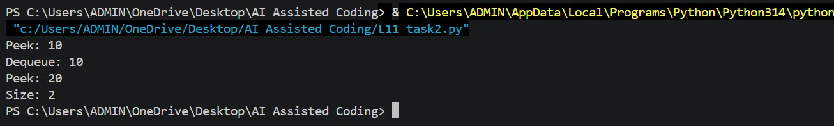

Task Description #3 – Linked List
Task: Use AI to generate a Singly Linked List with insert and display methods.
Input Code:
class Node:
def __init__(self, data):
self.data = data
self.next = None
class LinkedList:
def __init__(self):
self.head = None
def insert(self, data):
new_node = Node(data)
if self.head is None:
self.head = new_node
return
current = self.head
while current.next:
current = current.next
current.next = new_node
def display(self):
current = self.head
while current:
print(current.data, end=" -> ")
current = current.next
print("None")
linked_list = LinkedList()
linked_list.insert(10)
linked_list.insert(20)
linked_list.insert(30)
linked_list.display()

Output:

Task Description #4 – Binary Search Tree (BST)
Task: Use AI to create a BST with insert and in-order traversal methods.
Input Code:
class Node:
def __init__(self, data):
self.data = data
self.left = None
self.right = None
class BST:
def __init__(self):
self.root = None
def insert(self, data):
self.root = self._insert_recursive(self.root, data)
def _insert_recursive(self, node, data):
if node is None:
return Node(data)
if data < node.data:
node.left = self._insert_recursive(node.left, data)
else:
node.right = self._insert_recursive(node.right, data)
return node
def inorder(self, node):
if node:
self.inorder(node.left)
print(node.data, end=" ")
self.inorder(node.right)
bst = BST()
bst.insert(50)
bst.insert(30)
bst.insert(70)
bst.insert(20)
bst.insert(40)
bst.inorder(bst.root)

Output: 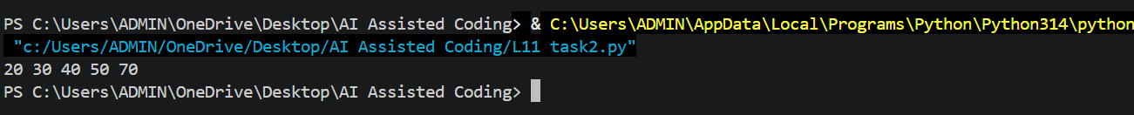

Task Description #5 – Priority Queue
Task: Use AI to implement a priority queue using Python’s heapq module.
Input Code:
import heapq
class PriorityQueue:
def __init__(self):
self.items = []
def enqueue(self, item, priority):
heapq.heappush(self.items, (priority, item))
def dequeue(self):
if not self.items:
return None
priority, item = heapq.heappop(self.items)
return item
def display(self):
for priority, item in sorted(self.items):
print(item, ":", priority)
pq = PriorityQueue()
pq.enqueue("Task A", 3)
pq.enqueue("Task B", 1)
pq.enqueue("Task C", 2)
pq.display()
print("Removed:", pq.dequeue())

Output:
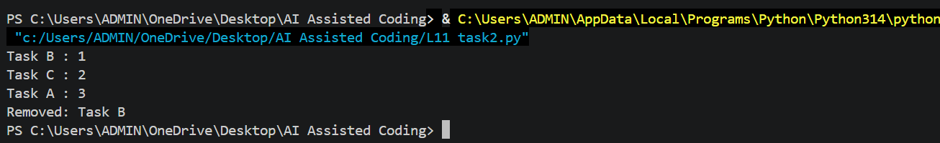

Task Description #6 – Deque
Task: Use AI to implement a double-ended queue using collections.deque.
Input Code:
from collections import deque
class DequeDS:
def __init__(self):
self.items = deque()
def add_front(self, item):
self.items.appendleft(item)
def add_rear(self, item):
self.items.append(item)
def remove_front(self):
if not self.items:
return None
return self.items.popleft()
def remove_rear(self):
if not self.items:
return None
return self.items.pop()
dq = DequeDS()
dq.add_front(10)
dq.add_rear(20)
dq.add_rear(30)
print(dq.remove_front())
print(dq.remove_rear())

Output:
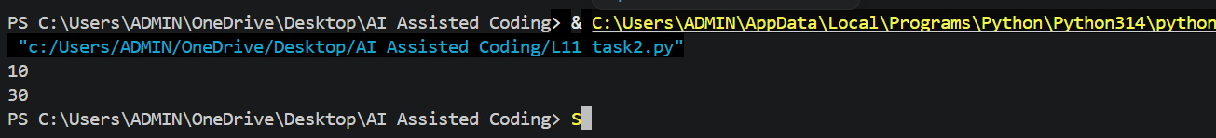

Task Description #7 – Real-Time Application Challenge – Choose the Right Data Structure
Task: Your college wants to develop a Campus Resource Management System that handles:
1. Student Attendance Tracking – Daily log of students entering/exiting the campus.
2. Event Registration System – Manage participants in events with quick search and removal.
3. Library Book Borrowing – Keep track of available books and their due dates.
4. Bus Scheduling System – Maintain bus routes and stop connections.
5. Cafeteria Order Queue – Serve students in the order they arrive.
For each feature, select the most appropriate data structure from the list: Stack, Queue, Priority Queue, Linked List, Binary Search Tree (BST), Graph, Hash Table, Deque. Justify your choice in 2–3 sentences per feature. Implement one selected feature as a working Python program with AI-assisted code generation.
Input Code:
class Queue:
def __init__(self):
self.items = []
def enqueue(self, item):
self.items.append(item)
def dequeue(self):
if not self.items:
return None
return self.items.pop(0)
def display(self):
print("Queue:", self.items)
cafeteria_queue = Queue()
cafeteria_queue.enqueue("Student A")
cafeteria_queue.enqueue("Student B")
cafeteria_queue.enqueue("Student C")
cafeteria_queue.display()
print("Served:", cafeteria_queue.dequeue())
cafeteria_queue.display()

Output:
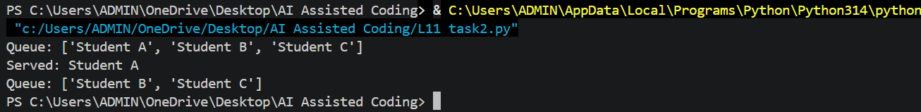

Task Description #8 – Smart E-Commerce Platform – Data Structure Challenge
Task: An e-commerce company wants to build a Smart Online Shopping System with:
1. Shopping Cart Management – Add and remove products dynamically.
2. Order Processing System – Orders processed in the order they are placed.
3. Top-Selling Products Tracker – Products ranked by sales count.
4. Product Search Engine – Fast lookup of products using product ID.
5. Delivery Route Planning – Connect warehouses and delivery locations.
For each feature, select the most appropriate data structure from the list: Stack, Queue, Priority Queue, Linked List, Binary Search Tree (BST), Deque. Justify your choice in 2–3 sentences per feature. Implement one selected feature as a working Python program with AI-assisted code generation.
Input Code:
class Queue:
def __init__(self):
self.items = []
def enqueue(self, item):
self.items.append(item)
def dequeue(self):
if not self.items:
return None
return self.items.pop(0)
def display(self):
print("Orders:", self.items)
order_queue = Queue()
order_queue.enqueue("Order #101")
order_queue.enqueue("Order #102")
order_queue.enqueue("Order #103")
order_queue.display()
print("Processed:", order_queue.dequeue())
order_queue.display()

Output:
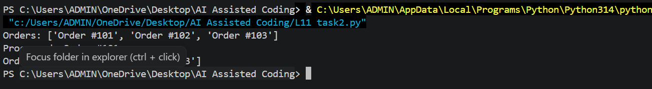

Task Description #5 – Priority Queue
Task: Use AI to implement a priority queue using Python’s heapq module.
Input Code:
import heapq
class PriorityQueue:
def __init__(self):
self.items = []
def enqueue(self, item, priority):
heapq.heappush(self.items, (priority, item))
def dequeue(self):
if not self.items:
return None
priority, item = heapq.heappop(self.items)
return item
def display(self):
for priority, item in sorted(self.items):
print(item, ":", priority)
pq = PriorityQueue()
pq.enqueue("Task A", 3)
pq.enqueue("Task B", 1)
pq.enqueue("Task C", 2)
pq.display()
print("Removed:", pq.dequeue())

Output:

Task Description #6 – Deque
Task: Use AI to implement a double-ended queue using collections.deque.
Input Code:
from collections import deque
class DequeDS:
def __init__(self):
self.items = deque()
def add_front(self, item):
self.items.appendleft(item)
def add_rear(self, item):
self.items.append(item)
def remove_front(self):
if not self.items:
return None
return self.items.popleft()
def remove_rear(self):
if not self.items:
return None
return self.items.pop()
dq = DequeDS()
dq.add_front(10)
dq.add_rear(20)
dq.add_rear(30)
print(dq.remove_front())
print(dq.remove_rear())

Output:

Task Description #7 – Real-Time Application Challenge – Choose the Right Data Structure
Task: Your college wants to develop a Campus Resource Management System that handles:
1. Student Attendance Tracking – Daily log of students entering/exiting the campus.
2. Event Registration System – Manage participants in events with quick search and removal.
3. Library Book Borrowing – Keep track of available books and their due dates.
4. Bus Scheduling System – Maintain bus routes and stop connections.
5. Cafeteria Order Queue – Serve students in the order they arrive.
For each feature, select the most appropriate data structure from the list: Stack, Queue, Priority Queue, Linked List, Binary Search Tree (BST), Graph, Hash Table, Deque. Justify your choice in 2–3 sentences per feature. Implement one selected feature as a working Python program with AI-assisted code generation.
Input Code:
class Queue:
def __init__(self):
self.items = []
def enqueue(self, item):
self.items.append(item)
def dequeue(self):
if not self.items:
return None
return self.items.pop(0)
def display(self):
print("Queue:", self.items)
cafeteria_queue = Queue()
cafeteria_queue.enqueue("Student A")
cafeteria_queue.enqueue("Student B")
cafeteria_queue.enqueue("Student C")
cafeteria_queue.display()
print("Served:", cafeteria_queue.dequeue())
cafeteria_queue.display()

Output:

Task Description #8 – Smart E-Commerce Platform – Data Structure Challenge
Task: An e-commerce company wants to build a Smart Online Shopping System with:
1. Shopping Cart Management – Add and remove products dynamically.
2. Order Processing System – Orders processed in the order they are placed.
3. Top-Selling Products Tracker – Products ranked by sales count.
4. Product Search Engine – Fast lookup of products using product ID.
5. Delivery Route Planning – Connect warehouses and delivery locations.
For each feature, select the most appropriate data structure from the list: Stack, Queue, Priority Queue, Linked List, Binary Search Tree (BST), Deque. Justify your choice in 2–3 sentences per feature. Implement one selected feature as a working Python program with AI-assisted code generation.
Input Code:
class Queue:
def __init__(self):
self.items = []
def enqueue(self, item):
self.items.append(item)
def dequeue(self):
if not self.items:
return None
return self.items.pop(0)
def display(self):
print("Orders:", self.items)
order_queue = Queue()
order_queue.enqueue("Order #101")
order_queue.enqueue("Order #102")
order_queue.enqueue("Order #103")
order_queue.display()
print("Processed:", order_queue.dequeue())
order_queue.display()

Output:

